Marvell MV98DX4122交换机内核无启动信息调试

在调试Marvell的Uboot的时候遇到了phy不通的问题。由于有一套通的linux kernel可以参考。所以想先调试kernel。

但kernel在启动的时候并没有在串口打印启动信息。而且在内核添加的打印也没有正常在串口输出。效果如下：

Marvell>> reset

Starting generic boot ...

Hardware DeviceID: E7FB

Hardware RevisionID: 3

Found parameters for Hardware DeviceID.

Copying image to DRAM... Done.

Verifying image... Done.

Hit any key to stop autoboot: 0

temperature = 71

temperature = 71

temperature = 71

temperature = 71

temperature = 71

Now Load Kernel......

* Loading kernel modules...

* Loading switch environment variables... [OK]

* Loading switch hardware drivers... [OK]

* Loading switch core modules... [OK]

Loading saved configuration ....

Welcome to switch console management system.

Copyright (c) BroadWit 2009-2019.All rights reserved.

Press '<ENTER>' to login

命令行已经打印出来了，说明串口驱动应该是好的。

为了确认还是看了下代码。

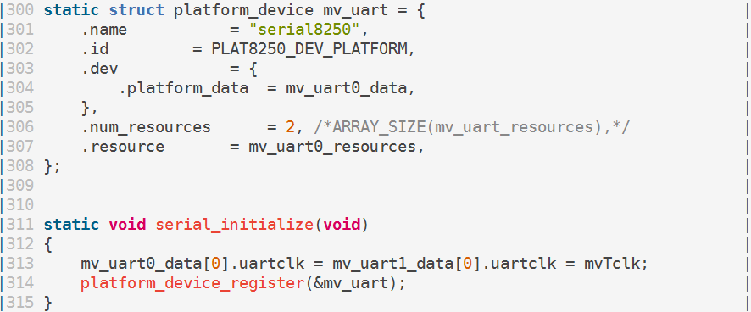

设备serial8250已经初始化了，因为Uboot的打印也正常所以对比了Uboot的地址等发现应该没问题。

再确认serial8250驱动

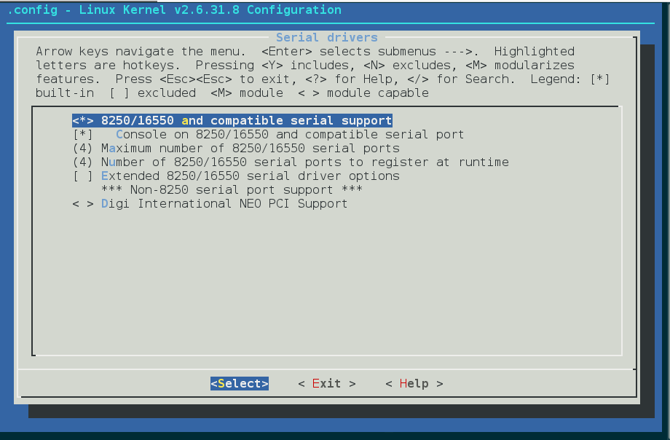

驱动也编译到内核了，可是为什么不打印启动信息和调试信息呢?

驱动的问题排除了，只能是内核的配置问题了。

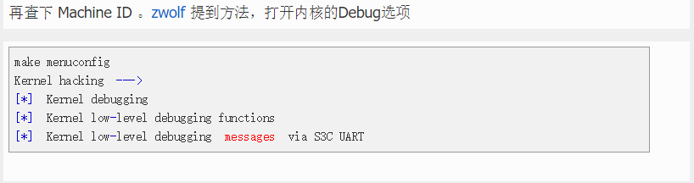

通过以上配置，打印终于出来了

Marvell>> reset

Starting generic boot ...

Hardware DeviceID: E7FB

Hardware RevisionID: 3

Found parameters for Hardware DeviceID.

Copying image to DRAM... Done.

Verifying image... Done.

Hit any key to stop autoboot: 0

temperature = 71

temperature = 71

temperature = 71

temperature = 71

temperature = 71

Now Load Kernel......

<5>Linux version 2.6.31.8 (demonelf@bogon) (gcc version 4.3.2 (sdk3.2rc1-ct-ng-1.4.1) ) #16 Fri Jul 15 10:20:55 CST 2016

CPU: Feroceon 88FR131 [56251311] revision 1 (ARMv5TE), cr=000539f7

CPU: VIVT data cache, VIVT instruction cache

Machine: Feroceon-KW

>>> marvell memory , VMALLOC_START=0x00800000, VMALLOC_END=0xe0000000<<<

>>> mv_high_memory_paddr = 0x0f000000

>>> mv_high_memory_vaddr = 0xef000000

>>> mv_high_memory_vaddr_top = 0xf0000000

Using UBoot passing parameters structure

BoardID=10

Memory policy: ECC disabled, Data cache writeback

<7>On node 0 totalpages: 61440

<7>free_area_init_node: node 0, pgdat c03003d8, node_mem_map c032e000

<7> Normal zone: 480 pages used for memmap

<7> Normal zone: 0 pages reserved

<7> Normal zone: 60960 pages, LIFO batch:15

calling iotable_init. MEM_TABLE=

virt=0xef000000, phys=0x0f000000, lengh=0x01000000

virt=0xe0000000, phys=0xe0000000, lengh=0x08000000

virt=0xf1000000, phys=0xf1000000, lengh=0x00100000

virt=0xf8000000, phys=0xf8000000, lengh=0x02000000

virt=0xf4000000, phys=0xf4000000, lengh=0x04000000

virt=0xfb000000, phys=0xfb000000, lengh=0x00010000

virt=0xf2000000, phys=0xf2000000, lengh=0x00010000

Internal prestera id register = 0x000e7fb3

xCat revision = A1

Built 1 zonelists in Zone order, mobility grouping on. Total pages: 60960

<5>Kernel command line: root=/dev/mtdblock2 rw rootfstype=jffs2 console=ttyS0,115200 mtdparts=spi_flash:0x00100000(uboot)ro,0x001c0000(kernel),0x01a00000(rootfs),0x00340000(config)

PID hash table entries: 1024 (order: 10, 4096 bytes)

<6>Dentry cache hash table entries: 32768 (order: 5, 131072 bytes)

<6>Inode-cache hash table entries: 16384 (order: 4, 65536 bytes)

<6>Memory: 240MB = 240MB total

<5>Memory: 240128KB available (2748K code, 279K data, 92K init, 0K highmem)

<6>Hierarchical RCU implementation.

<6>NR_IRQS:128

Console: colour dummy device 80x30

<6>Calibrating delay loop... <c>333.41 BogoMIPS (lpj=1667072)

Mount-cache hash table entries: 512

<6>CPU: Testing write buffer coherency: ok

<6>NET: Registered protocol family 16

<6>Feroceon L2: Enabling L2

<6>Feroceon L2: Cache support initialised.

CPU Interface

-------------

SDRAM_CS0 ....base 00000000, size 256MB

SDRAM_CS1 ....disable

SDRAM_CS2 ....disable

SDRAM_CS3 ....disable

PEX0_MEM ....base e8000000, size 128MB

PEX0_IO ....base fc000000, size 1MB

INTER_REGS ....base f1000000, size 1MB

NFLASH_CS ....base d8000000, size 128MB

SPI_CS ....base f8000000, size 32MB

BOOT_ROM_CS ....no such

DEV_BOOTCS ....no such

CRYPT_ENG ....base fb000000, size 64KB

PP_UNIT ....base f4000000, size 64MB

DRAGONITE_DTCM ....no such

Marvell Development Board (LSP Version KW_LSP_5.4.0_012)-- DB-98DX4122-48G Soc: MV88F6281 Rev 3 BE

Detected Tclk 167000000 and SysClk 166500000

Switch decoding windows init is done.

<5>MV Buttons Device Load

>>>>> MV Buttons generating to many interrupts. Disabled <<<<<

PEX0 interface detected no Link.

<6>PCI: bus0: Fast back to back transfers enabled

bio: create slab <bio-0> at 0

<6>cfg80211: Calling CRDA to update world regulatory domain

<6>NET: Registered protocol family 2

<6>IP route cache hash table entries: 2048 (order: 1, 8192 bytes)

<6>TCP established hash table entries: 8192 (order: 4, 65536 bytes)

<6>TCP bind hash table entries: 8192 (order: 3, 32768 bytes)

<6>TCP: Hash tables configured (established 8192 bind 8192)

<6>TCP reno registered

<6>NET: Registered protocol family 1

<6>XOR registered 4 channels

<6>XOR 2nd invalidate WA enabled

<6>JFFS2 version 2.2. (NAND) Â© 2001-2006 Red Hat, Inc.

<6>msgmni has been set to 469

<6>io scheduler noop registered

<6>io scheduler anticipatory registered (default)

<6>Serial: 8250/16550 driver, 4 ports, IRQ sharing disabled

<6>serial8250.0: ttyS0 at MMIO 0xf1012000 (irq = 33) is a 16550A

<6>console [ttyS0] enabled

Loading Marvell Ethernet Driver:

o Cached descriptors in DRAM

o DRAM SW cache-coherency

o 1 Giga ports supported

o Single RX Queue support - ETH_DEF_RXQ=0

o Single TX Queue support - ETH_DEF_TXQ=0

o TCP segmentation offload (TSO) supported

o Large Receive offload (LRO) supported

o Receive checksum offload supported

o Transmit checksum offload supported

o Network Fast Processing (Routing) supported - (Disabled)

o Driver ERROR statistics enabled

o Driver INFO statistics enabled

o Proc tool API enabled

o SKB Reuse supported - (Disabled)

o SKB Recycle supported - (Disabled)

o Rx descripors: q0=128

o Tx descripors: q0=532

o Loading network interface(s):

o registered under mv88fx_eth platform

o eth0, ifindex = 31, GbE port = 0

mvFpRuleDb (ce07c000): 2048 entries, 8192 bytes

flashProbe flash phys=0xf8000000 flash size=33554432

SPI Serial flash detected @ 0xf8000000, 32768KB (512sec x 64KB)

<5>4 cmdlinepart partitions found on MTD device spi_flash

<5>Creating 4 MTD partitions on "spi_flash":

<5>0x000000000000-0x000000100000 : "uboot"

<5>0x000000100000-0x0000002c0000 : "kernel"

<5>0x0000002c0000-0x000001cc0000 : "rootfs"

<5>0x000001cc0000-0x000002000000 : "config"

NAND init: NAND device not found on board

<6>mice: PS/2 mouse device common for all mice

<6>i2c /dev entries driver

<6>TCP cubic registered

<6>NET: Registered protocol family 17

<6>RPC: Registered udp transport module.

<6>RPC: Registered tcp transport module.

<6>802.1Q VLAN Support v1.8 Ben Greear <greearb@candelatech.com>

<6>All bugs added by David S. Miller <davem@redhat.com>

pp_nics_config: ifconfig up: p0 p1 p2 p3 p4 p5 p6 p7 p8 p9 p10 p11 p12 p13 p14 p15 p16 p17 p18 p19 p20 p21 p22 p23 p24 p25 p26 p27

VFS: Mounted root (jffs2 filesystem) on device 31:2.

<6>Freeing init memory: 92K

<5>eth0: started

<5>eth0: stopped

* Loading kernel modules...

<7>mvKernelExt_init

<7>mvKernelExt_major = 254 cdev.dev=fe00001

<7>mvKernelExt_init finished

<7>prestera_init

<7>prestera_major = 254

bspDragoniteSharedMemoryBaseAddrGet failed

<7>presteraSmi_init Oct 15 2014

presteraSmi_init: Init OK!

DMA - dma_area: 0xef000000(v) ,dma_base: 0xf000000(p), dma_len: 0x200000

HSU - hsu_area: 0xbad0bad0(v) ,hsu_base: 0xfad0bad0(p), hsu_len: 0x800000

<7>prestera_init finished

* Loading switch environment variables... [OK]

* Loading switch hardware drivers...